B.M. INSTITUTE OF ENGG. &

TECH., SONIPAT


SESSION (2017-2021)

SYNOPSIS
MAJOR PROJECT
ON

Generic Automation Vision Inspection

Submitted to: Submitted by:
Pradeep Tyagi
SHIVA CHAUHAN (CSE/17/227)
TANISHQ (CSE/17/247)
HARSH (CSE/17/137)

Generic Automatic Vision Inspection System

PROBLEM STATEMENT

GAVI(generic automatic vision inspection system) Generic Automation Vision inspection (sometimes referred to as machine vision systems) provide image-based inspection automated for your convenience for a variety of industrial and manufacturing applications. Inspection of components using machine vision technologies provides solution for quality and process control.

INTRODUCTION

The basic idea of this project is to make aware of machine vision technology and to improve the production quality, reduce the scrap product due to non-conformity by controlling the manufacturing process through machine vision and also to prevent the value addition for scrap product in the subsequent stage of manufacturing process. Generic Automation Vision inspection (sometimes referred to as machine vision systems) provide image-based inspection automated for your convenience for a variety of industrial and manufacturing applications.

OBJECTIVE-

To Make a GAVI using Machine Learning that will improve the production quality, reduce the scrap product due to non-conformity by controlling the manufacturing process through machine vision.

METHODOLOGY-

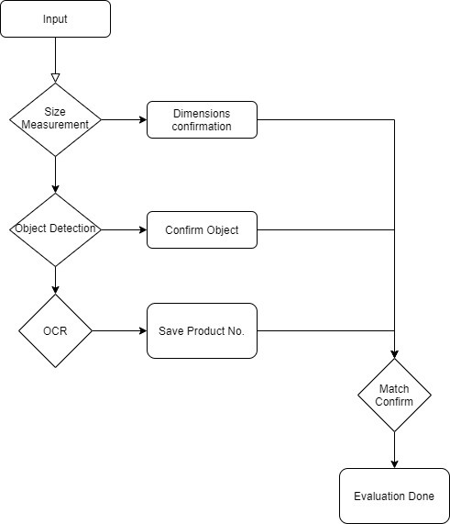
- Image pre-processing
- Read an image and convert it it no grayscale
- Blur the image using Gaussian Kernel to remove un-necessary edges
- Edge detection using Canny edge detector
- Perform morphological closing operation to remove noisy contours
- Object Segmentation
- Find contours
- Remove small contours by calculating its area (threshold used here is 100)
- Sort contours from left to right to find the reference objects
- Reference object
- Calculate how many pixels are there per metric (centi meter is used here)
- Compute results
- Draw bounding boxes around each object and calculate its height and width.

Algorithm:

Haar:
Haar like features are digital image features used in object detection. Or we can say that these are rectangle shaped dark and light areas having similar kind of features like our face. So basically, we move those features throughout our face to find the output of each feature.

For example:

All faces share some similar properties

- The eyes region is darker than the upper-cheeks.

- The nose bridge region is brighter than the eyes.
So, this feature of face are used for developing haar like features.

Each feature is related to a special location in the face.

Output of Rectangle features:

We will move the related kind of rectangle throughout the face to get different values.

- Value = ∑ (pixels in black area) - ∑ (pixels in white area).

- Three types: two-, three-, four-rectangles, Viola and Jones used two-rectangle features.

    - Edge Features

  - Line Features
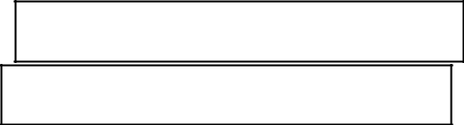

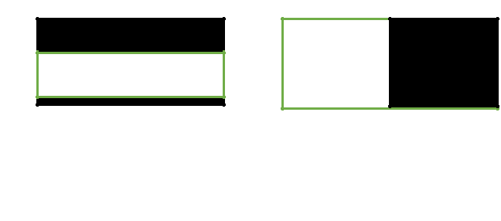
Figure 4: Different features used

for Haar cascade


5.2.3 Integral Image
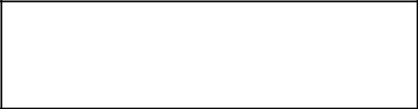

(c) Four rectangle features

We know each point of an image is represented by a

pixel value. As we so we need to know the output of applied Haar features so we need to find the sum of pixel value of all those area and solve the summation. But this is a huge task. To reduce the number of calculation concept of INTEGRAL IMAGE is introduced.

Definition of Integral Image:

Basically Integral image is a matrix same as size of the window. The integral image at location (x, y) is the sum of the pixels above and to the left of (x, y).

For example
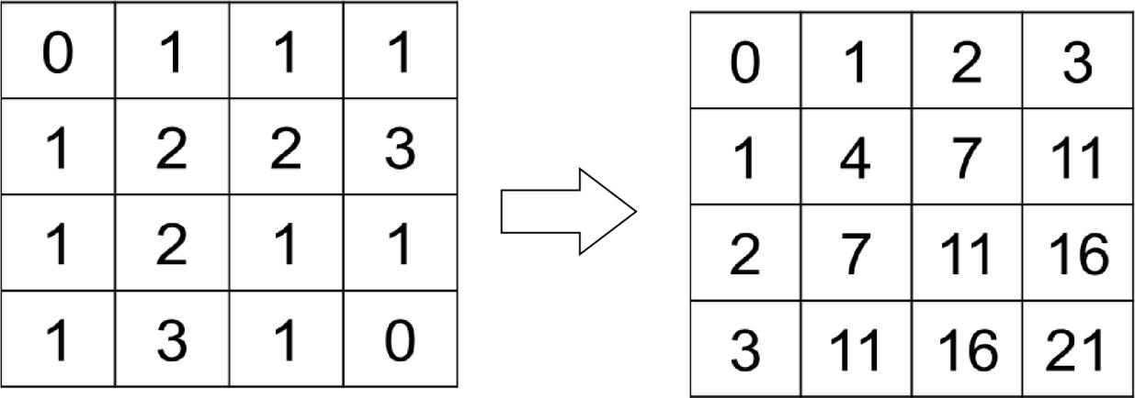

Figure 5: figure shows integral image formation

Here the pixel value of each box is modified by sum of all those box left and above it so that we can use a formula mentioned below to get the output of Haar features with much less calculation reducing the time of calculation.
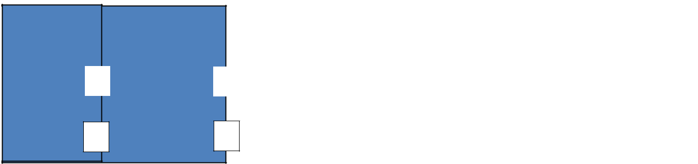

For example the integral sum of inside rectangle can be
 | a |  | c |  | computed as:
 |  |  |  |  | ii ( d) + ii ( a) – ii ( b) – ii ( c)
Where ii stands for integral image value.
b d

Figure 6: Integral image calculation

Hence if we want to calculate the pixel value of a rectangle we can do so by just taking four points from integral image as above.

5.2.4 AdaBoost

Adaboost stands for “Adaptive” boost. Here we construct a strong classifier as linear combination of weak classifier as there are so many features which are absolutely invalid in finding the facial features. It can be formulated as below:
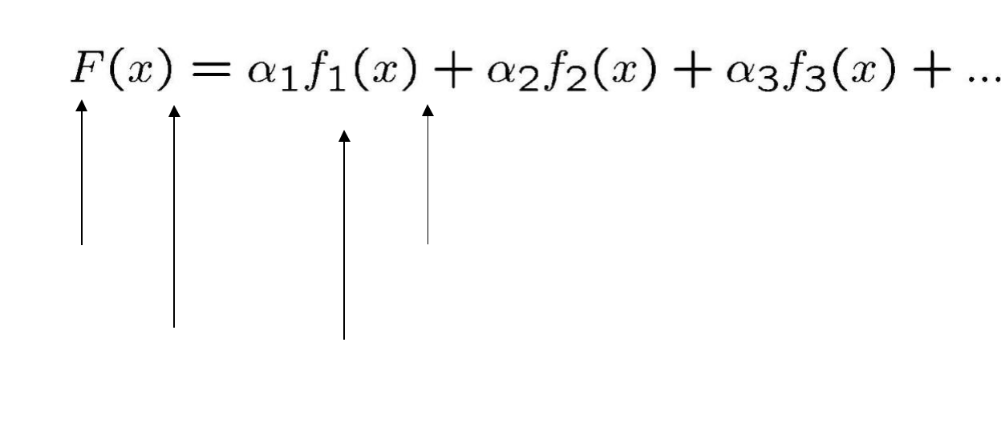

Strong Weak classifier
Classifier
^{Image} Weight

Features of weak classifiers:

Each single rectangle is regarded as a simple weak classifier. Each weak classifier is assigned a weigh function as per its importance of position. Finally the strong classifier is formed by their linear combination.

5.2.5 Cascade

After going through Adaboost stage now let’s say we have 600 no of strong classifiers. So to detect if a frame contains a face or not: Instead of applying all the 600 features on

- window, group the features into different stages of classifiers and apply one-by-one. If a window fails the first stage, discard it. We don't consider remaining features on it. If it passes, apply the second stage of features and continue the process. The window which passes all stages is a face region.

Canny Edge Detection:
Canny edge detection is a technique to extract useful structural information from different vision objects and dramatically reduce the amount of data to be processed. It has been widely applied in various computer vision systems. Canny has found that the requirements for the application of edge detection on diverse vision systems are relatively similar. Thus, an edge detection solution to address these requirements can be implemented in a wide range of situations. The general criteria for edge detection include:
- Detection of edge with low error rate, which means that the detection should accurately catch as many edges shown in the image as possible
- The edge point detected from the operator should accurately localize on the center of the edge.
- A given edge in the image should only be marked once, and where possible, image noise should not create false edges.
- It is a multi-stage algorithm and we will go through each stage.
- Noise Reduction
Since edge detection is susceptible to noise in the image, first step is to remove the noise in the image with a 5x5 Gaussian filter. We have already seen this in previous chapters.
- Finding Intensity Gradient of the Image
Smoothened image is then filtered with a Sobel kernel in both horizontal and vertical direction to get first derivative in horizontal direction ( Gx) and vertical direction ( Gy). From these two images, we can find edge gradient and direction for each pixel as follows:
Edge_Gradient(G)=G2x+G2y−−−−−−−√Angle(θ)=tan−1(GyGx)
Gradient direction is always perpendicular to edges. It is rounded to one of four angles representing vertical, horizontal and two diagonal directions.
- Non-maximum Suppression
After getting gradient magnitude and direction, a full scan of image is done to remove any unwanted pixels which may not constitute the edge. For this, at every pixel, pixel is checked if it is a local maximum in its neighborhood in the direction of gradient. Check the image below:
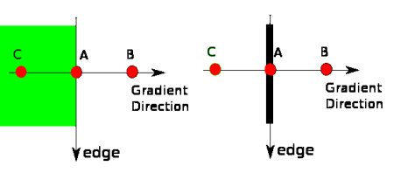
image
Point A is on the edge ( in vertical direction). Gradient direction is normal to the edge. Point B and C are in gradient directions. So point A is checked with point B and C to see if it forms a local maximum. If so, it is considered for next stage, otherwise, it is suppressed ( put to zero).
In short, the result you get is a binary image with "thin edges".
- Hysteresis Thresholding
This stage decides which are all edges are really edges and which are not. For this, we need two threshold values, minVal and maxVal. Any edges with intensity gradient more than maxVal are sure to be edges and those below minVal are sure to be non-edges, so discarded. Those who lie between these two thresholds are classified edges or non-edges based on their connectivity. If they are connected to "sure-edge" pixels, they are considered to be part of edges. Otherwise, they are also discarded. See the image below:
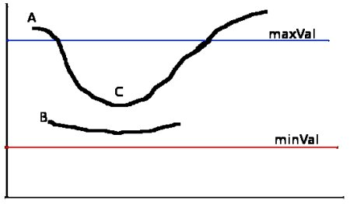
image
The edge A is above the maxVal, so considered as "sure-edge". Although edge C is below maxVal, it is connected to edge A, so that also considered as valid edge and we get that full curve. But edge B, although it is above minVal and is in same region as that of edge C, it is not connected to any "sure-edge", so that is discarded. So it is very important that we have to select minVal and maxVal accordingly to get the correct result. This stage also removes small pixels noises on the assumption that edges are long lines.So what we finally get is strong edges in the image.
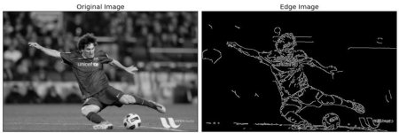

SOFTWARE USED

- OpenCV – pip install OpenCV-python (face and eye detection).
- TensorFlow– pip install tensorflow (to build our model).
- Tkinter – pip install Tkinter (for GUI)
- Jupyter

HARDWARE USED

A system with modules installed in it. And a mobile camera connected to system with droid cam.

EXPECTED OUTCOME

It will improve the production quality, reduce the scrap product due to non-conformity by controlling the manufacturing process.

